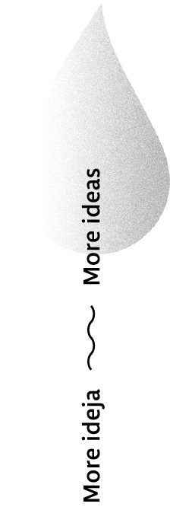


PRELIMINARY QUALITY CONTROL OF THE DOCTORAL DISSERTATION

General information and contact of the doctoral candidate
Title, first name and surname of the doctoral candidate
Provider of the study program | Faculty of Economics and Business, University of Rijeka
Name of the study program | Postgraduate Doctoral Study Program in Economics and Business Economics
Identification number of the doctoral candidate
Title of the doctoral dissertation | Language in which the doctoral dissertation is written | Croatian/English
 | Croatian
 | English
Area/field

- SUPERVISOR/SUPERVISORS

1.1. Supervisor/Supervisors
Title, first name and surname | Institution, country
1.2. Co-supervisor/Co-supervisors
Title, first name and surname | Institution, country

- Preliminary Quality Control Report
2.1. Report*
(The Preliminary Quality Control Report includes comments on the quality of the following elements of the doctoral dissertation: suitability of the title of the dissertation, connection of the results with the research questions posed and hypotheses set, suitability of the methodology used, relevance of research results, connection of the research results with current research)
*(Questions posed to the doctoral candidate during the presentation of the research results are an integral part of the report.)
2.2. Opinion and proposal
(Proposal a, b or c in accordance with Article 34 of the Regulations)
2.3. The selected Committee for Preliminary Quality Control of the Doctoral Dissertation
Title, first name and surname, institution, country | Signature:
2.4. Meeting of the competent authority and item on the meeting agenda under which the Committee was appointed
2.5. Additional comment
(if applicable)
In Rijeka, dd.mm.yyyy Stamp

